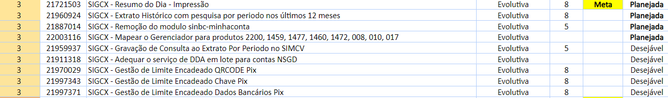

https://gid.caixa:9443/ccm/web/projects/Comunidade%20Canais%20Digitais#action=com.ibm.team.apt.viewPlan&page=com.ibm.team.apt.web.ui.plannedItems&id=_0_l3cDokEe-LSetGIu_2yg&planMode=f3c657e2-8c2c-4658-ab77-b8fee1d76149

